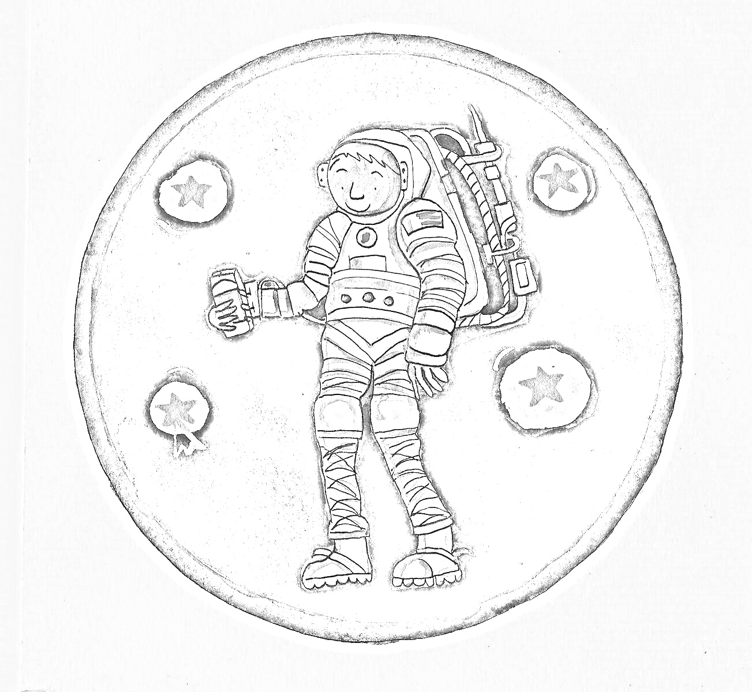
Astronaut- Can you colour in this astronaut with a night sky?

